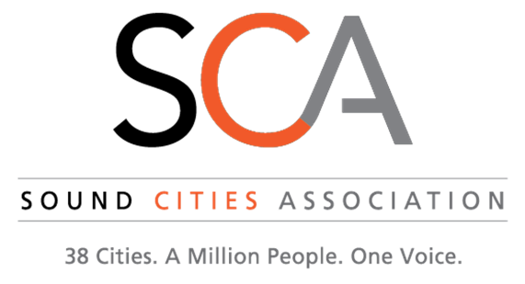
Leadership Advisory Council Meeting
February 5, 2020 11:30 AM
River Rock Grill, Maplewood Golf Course, 4050 Maple Valley Highway, Renton, WA 98058

AGENDA

11:45 Welcome

11:50 Confirm location, time, and format for 2020 meetings

11:55 Role of LAC

12:00 Recap of 2020 SCA Retreat

12:15 Discussion Items:
- Proposed Business Tax
- Other Legislative Items
- Transportation/METRO
- Regional Homelessness Authority
- VISION 2050
- Prosecution Standards
- Other?

12:55 SCA Events
- Debrief of recent SCA orientations
- Upcoming PIC orientation
- SCA Networking Events
12:10 For the Good of the Order
1:15 Adjourn

