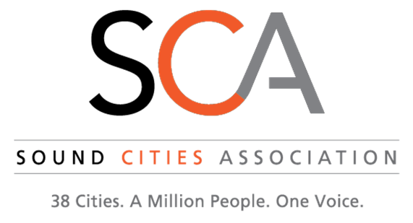
Leadership Advisory Council Meeting
March 4, 2020 11:45 AM
River Rock Grill, Maplewood Golf Course, 4050 Maple Valley Highway, Renton, WA 98058

AGENDA

11:45 Welcome

11:50 Discussion Items:
- COVID-19
- Transportation/METRO
- Regional Homelessness Authority
- Proposed Business Tax
- Other Legislative Items
- VISION 2050
- Prosecution Standards
- Other?

12:50 2020 SCA Events
- Debrief Recent Events
- Upcoming Networking Event
- 2020 Trainings
- Future SCA Networking Events
1:05 Next Meeting
1:10 For the Good of the Order
1:15 Adjourn

